Process to compare Work-flow in SMP box

Login to workflow builder and filter the workflow with its name.

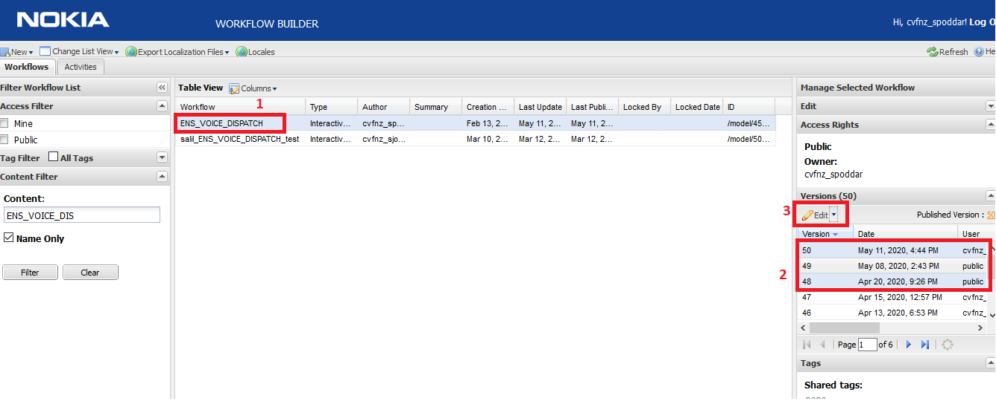

Step :1

Select the workflow form the list of suggestion

Step :2

After selecting the WF you will be having list of previous version on the right side which I have highlighted above, from this list of version select any two version which you wanted to compare.

Step :3

After selecting version click on edit icon above version list.

Step :4

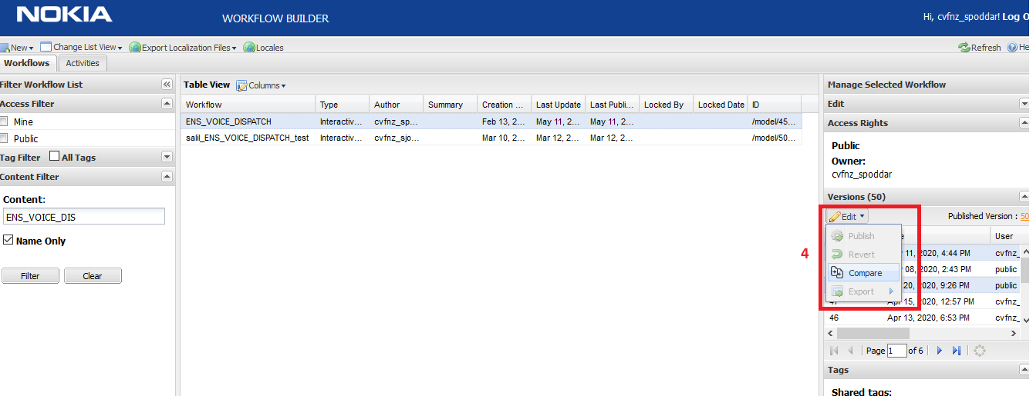

Once you expand the edit drop down you will be having compare option, on selection of compare option one new tab will open which will be having all comparison result.

I have attached the screenshot of comparison window below for your reference.

